**Project Design Phase – Part 1**

|  |  |
| --- | --- |
| Team ID | NM2023TMID02667 |
| Project name | *How to add google analytics to a website* |
| Date | 3 November 2023 |

**Proposed Solution**

Proposed Solution: Describe the solution you're proposing in detail. This could include technologies, methods, and strategies you plan to use.

Define the Project Scope: Clearly outline the objectives, deliverables, and constraints of the project. This sets the foundation for the entire design.

Gather Requirements: Identify and document the specific requirements and expectations of stakeholders. This includes functional, technical, and non-functional requirements.

Create a Project Charter: Develop a project charter that outlines the project's purpose, objectives, stakeholders, and initial high-level plan.

Design the Project Structure: Create a project organization structure, including roles and responsibilities for the project team members.

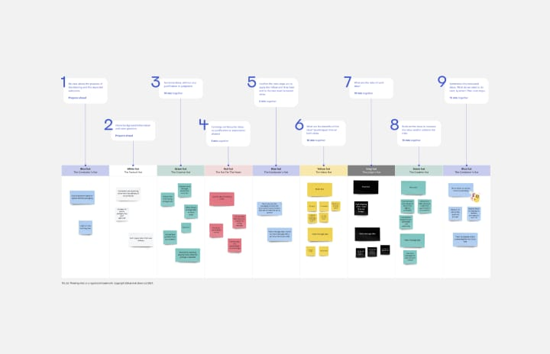

**Solution Architecture**

Solution architecture design incorporates the business vision and its implementation into a blueprint. The first version is created as part of the pre-sales process and forms the initial high-level understanding of what you plan to build.

Requirements Gathering: Begin by understanding and documenting the project's requirements, both functional and non-functional.

High-Level Design: Create a high-level overview of the solution, including components, data flows, and interactions. Consider architectural styles (e.g., client-server, microservices).

Security Design: Incorporate security measures like encryption, authentication, and authorization throughout the architecture.

Scalability: Ensure the architecture can handle future growth by designing for scalability, including load balancing and caching strategies.

Performance Optimization: Consider performance bottlenecks and design strategies to optimize system performance.

Documentation: Maintain comprehensive documentation that includes architectural diagrams, component descriptions, and guidelines for developers.

Deployment Strategy: Plan how the solution will be deployed, updated, and maintained.

Cost Analysis: Estimate the cost of implementing and maintaining the architecture, including infrastructure, licenses, and personnel.

